CHARACTERIZATION AND OPTIMIZATION OF SELECTED NEMATODES FOR INDUSTRIAL EFFLUENT
WATER TREATMENT
ZANKHANA R. PANDIT*, ASTHA BARIA, LINZ-BUOY GEORGE, HYACINTH HIGHLAND
Soil samples collected from different agricultural fields were examined for the existence of nematodes. Five different plant-parasitic nematodes species, i.e. Rotylenchus, Ditylenchus, Dorylaimoides and Trichodorus sp. and free living nematodes, i.e. Acrobeles were identified. Plant-parasitic nematodes (PPN) were cultivated on modified Nematode Growth Media (NGM) plates to select the most suitable species for treatment of industrial effluent water collected from waste water treatment plant (WWTP) outlet from Vasna. The positive or negative effect of effluent water on the survival of PPN was then calculated by measuring their Maturity Index (MI). From the results obtained, Dorylaimoides sp. was selected for further studies.
Keywords: Rotylenchus, Ditylenchus, Dorylaimoides, Trichodorus, Acrobeles.
INTRODUCTION
Environmental health and ecosystem sustainability is an important area of focus in current ecological and environmental research. Nematodes are among the simplest metazoa. They occur in any environment that offers a good source of organic carbon, in every single soil type, beneath all climatic conditions and in habitats that vary from pristine to extremely polluted area (Grzelak et al., 2016).
Due to their small sizes nematodes are in intimate contact with the sediment and are therefore, directly and indirectly influenced by the physical characteristics and chemical features of surroundings. Nematodes are considered as suitable taxa for practice in environmental monitoring and have been already implemented in many studies examining the impacts of anthropogenic and natural physical disturbances, environmental pollution and alteration in marine ecosystems. As was shown by Schwinghamer (1981), variation in body size is a major influence on the size distribution of sediment dwelling organisms. However, other biotic and abiotic factors such as sediment water content, oxygen concentration and organic content are all significant in decisive body size and properties. Nematode body length and width as well as length to width ratio, a quantitative measure of nematode shape are also considered to be valuable parameters imitating the state of ecosystem in which they inhabit.
In soil, nematodes live in capillary water; their penetrable cuticle provides direct connection with their microenvironment. They do not promptly migrate from stressful conditions and many species survive dehydration, freezing or oxygen stress (although others are more sensitive). The community structure is indicative of conditions in the soil horizon that it inhabits and hence nematodes are valuable indicators of environmental stress. Nematodes occupy key positions in soil food webs. They feed on most soil organisms and are food for many others. They also influence vegetation succession. A positive feature of nematodes being selected for study is that nematodes are transparent; their diagnostic internal features can be seen without dissection. They can therefore be identified without biochemical procedures. There is a clear relationship amongst structure and function: the feeding behavior is easily deduced from the structure of the mouth cavity and pharynx. Nematodes respond rapidly to disturbance and enrichment: increasing microbial activity leads to alterations in the proportion of bacterial feeders in a community. Nematodes were classified in two groups for environmental monitoring and ecological assessment i.e., opportunists and persistent species. Among which opportunists intensify in number more promptly than persistent species.
The main objectives of the present study are:
- To identify some of the plant parasitic nematodes and free living nematodes;
- To optimize their cultivation conditions;
- To evaluate their efficacy in remediating the industrial effluent water.
MATERIAL AND METHODS
During December 2018, soil samples and root samples were collected from depth of 15–20 cm, from Ahmedabad district (India) and were kept moist and contained in polyethylene bags. To avoid temperature fluctuation, the soil samples were stored in a cool and dry place between 16ºC–20ºC.
Extraction and handling of plant parasitic nematodes were carried out using basic materials like sieves, flasks, funnel, filter etc. For extraction of mobile plant parasitic nematodes, the sieving and filtration methods were used in which, mobile nematodes from roots and soil were first extracted by sieving method (Cobb, 1918) which was followed by filtration method (Hooper et al., 2005) for further removal of debris.
Direct examination for identification
A drop of extracted nematode suspension was examined directly under a stereo-binocular light microscope (Nikon) at magnification under 2X, 4X and 10X and photographed using Motic camera and Motic Image plus software. Nematodes could usually be seen by examining small amount of gently washed plant roots and soil with stereo microscope. Plant tissues were examined in water filled open petri dish. Nematodes were released from the soil and also from root. Afterward floating nematodes were collected with a small dropper.
Identification and classification
The taxonomic rank into which nematodes are placed varies in accordance with authors. Identification and classification of the selected species were carried out using the keys explained by Tarjan et al. (1977) and Mekete et al. (2012).
Collection of industrial effluent water
The selected site for the present study was waste water treatment plant (WWTP) outlets located at Vasna, Ahmedabad. The collection of water was carried out from one of the four outlets by following grab sampling method. The collected water was immediately stored in a cool dark place to avoid any chemical reaction. Afterwards the effect of WWTP effluent water on nematode growth and development was examined.
Cultivation of selected nematode species
Plant parasitic nematodes were maintained in laboratory conditions by using nematode growth medium (NGM) agar which was aseptically poured into petri plates. A constant amount of NGM agar was dispensed in to petri plates.
Cultivation of nematodes on NGM was carried out following the standard protocol of (Stiernagle 2006) with modification of food source in the form of nutrient mixture. The cultivation media for control NGM was deprived of industrial effluent water, conversely the cultivation media for treatment, comprised of four groups of varied concentration of WWTP viz., 20%, 30%, 40% and 100%.
Maturity Index (MI)
The MI (Bongers 1990; Bongers et al., 1991) was calculated as scores of the mean of the numbers of individual of the genera. Each group of nematodes was considered (c - p values) based on their numbers in control and treatment groups, which were used for the calculation.

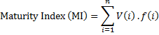

Where V (i) is the c - p score of genus (i); f (i) is the frequency of that genus in treatment sample and (i) is the number of genus chosen for study.
The values of MI further used for evaluation of nematode response to the industrial effluent water. In this study only one nematode genus was finally selected and frequency of these nematodes in waste water treated NGM was compared with frequency in control NGM. The frequency of nematodes (in numbers) in treated and control samples was measured depending upon their survival numbers. Since, the degree of nematode response to industrial effluent water was either in a positive or a negative way. The value for V (i) for different families of nematodes was obtained from the Bongers (1990).
Statistical analysis of the data
For each cultivation and WWTP test parameter 5–6 replicates were done. Values are expressed as mean ± S.E. The student’s t-test was used to verify the levels of significance at the p<0.05 value, using Microsoft Excel 2010.
RESULTS AND DISCUSSION
Identification
Altogether, five species of plant and soil free living nematodes belonging to the five different genera of five different families are identified: Dorylaimoides, Ditylenchus, Trichodorus, Acrobeles and Rotylenchus. Identification of these 5 generic nematodes was then followed by characterization: 1 – the nematode species identified from potato (Solanum tuberosum L.) soil sample is Acrobeles (Fig. 1) showed the annulation in cuticle, forked and elaborated lip appendages posteriorly located vulva and pointed tail terminus; 2 – the species of nematode from peepal tree (Ficus religiosa L.) stem galls was identified as Rotylenchus sp. (Fig. 2) showed kidney shaped female body, short tail, esophagus overlapping intestine; 3 – species from Fenugreek roots (Trigonella foenum-graecum L.) was identified as Ditylenchus sp. (Fig. 3) showed simple cuticle without annulation, pointed tail terminal, vulva was located at posterior third of the body; 4 – the species from spring onion (Allium cepa L.) was Dorylaimoides sp. (Fig. 4) showed Valvate median esophageal bulb, short and simple stylet, male with paired spicules; 5 – from Coriander root (Coriandrum sativum L.) was Trichodorus sp. (Fig. 5) as it showed the presence of wrinkled cuticle with thick layer and without median esophageal bulb and lip region without the setae.

- 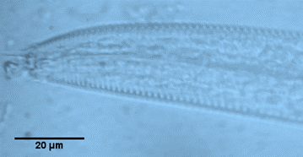 (B) 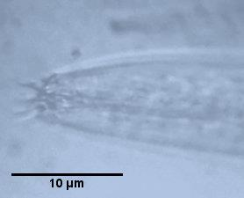

- 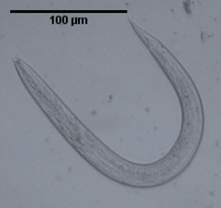 (D) 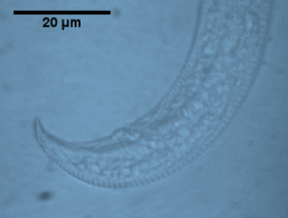
Fig. 1 – Acrobeles sp.: A) Annulated cuticle; B) Forked and elaborated lip appendages;
C) Whole body; D) Tail with posteriorly located vulva.

- 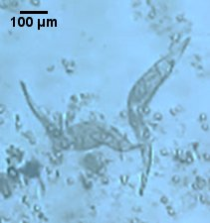 (B) 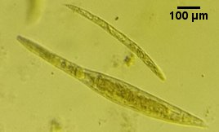
(C) 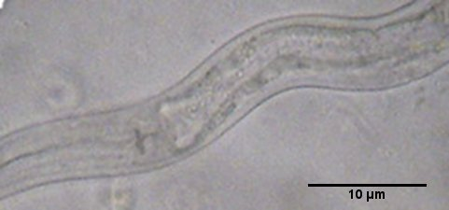
Fig. 2 – Rotylenchus sp.: A) Obese female with kidney shaped body and pointed short tail;
B) Death position of female; C) Posterior oesophageal bulb.

(A) 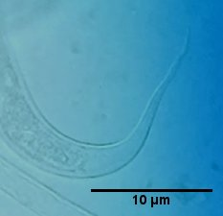 (B) 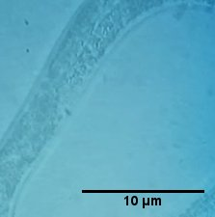
(C) 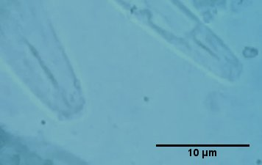 (D) 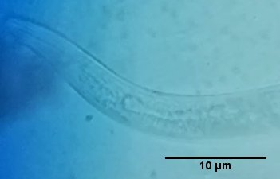
Fig. 3 – Ditylenchus sp.: A) Showing pointed tail; B) vulva at posterior third of the body;
C) Stylet without knob; D) Oesophagus overlapping intestine.

(A)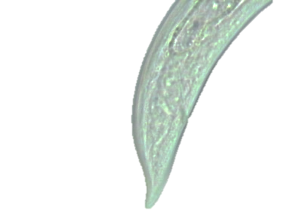 (B)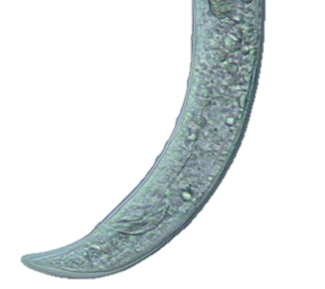
(C) 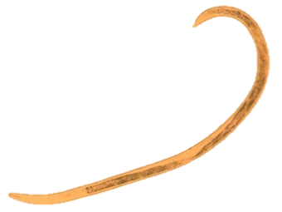 (D) 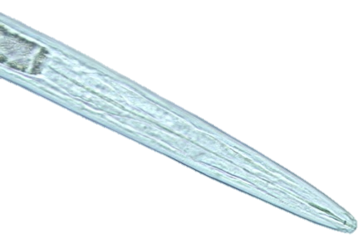
Fig. 4 – Dorylaimoides sp.: A) Female tail; B) Male tail terminus with spicule; C) whole body;
D) Stylet without knob and without median oesophageal bulb.
(Source: https://nematode.unl.edu/dorele.htm)
- 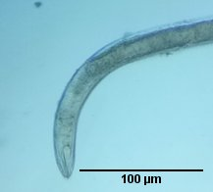 (B) 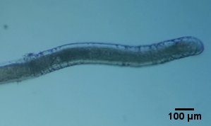
(C) 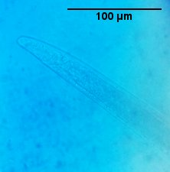
Fig. 5 – Trichodorus sp.: A) Whole body; B) Showing Wrinkled cuticle;
C) Blunted or round tail in female.
Cultivation of selected nematode species
For the selection of most adapted species under control NGM, the four plant parasitic nematode species were cultivated excluding the one free living nematode species of genus Acrobeles. All the species displayed growth and higher rate of increase under control NGM. The growth at 3rd day was found to be significant (p<0.05) for every nematode species (Table 1), while the growth at 6th day was highly significant smaller (p<0.01) for all cultivated nematode species as the number of nematode increased considerably. But after that, there is no significant increase in growth rate and hence, population of nematode species in all NGM plates reached its stable state with no further increase.
Table 1
Species specific growth pattern of nematodes upon cultivation on NGM
Number of days | Dorylaimoides  (Spring onion) | Ditylenchus  (Fenugreek) | Rotylenchus  (Peepal tree) | Trichodorus  (Coriander)
1 | 11.7±0.8 | 8.3±1.4 | 6.7±0.8 | 10.3±1.4
3 | 32.3±3.8* | 17.3±1.7* | 11±1.1* | 24.3±7.1*
6 | 67.3±10.6** | 42.3±9.7** | 53.6±15.4** | 48±6.6**
8 | 98.3±3.7* | 79.3±4.3* | 70.7±13.6* | 75±2.5*
11 | 146.3±12.4 | 95±9.1 | 89±13 | 98.3±2.0
14 | 199.3±31.5 | 123.3±28.3 | 103.7±8.7 | 151±1.73
Values are mean ± SEM, * = Significant (p < 0.05), ** = highly significant (p < 0.01) (n=6).

For each species, sub-culture was done twice. The data were composed and represented in Table 1. For up to four months the nematodes were allowed to grow on NGM plates and it was observed that different species had different growth patterns and multiplied at different rates and at different times. In all the cultivated species there was a sharp increase in number at 6th day of cultivation and it increased further up to day 8th. After two weeks on NGM plate there was no further increase in nematode population i.e., population reached its carrying capacity. This may occur due to the insufficient nutrient supply or insufficient space for lateral growth inside the plate. So after sub-culture, two observations were made and it was found that the data obtained were similarly.
In the species Dorylaimoides, there was a sharp increase in number at 6th day of cultivation and it increased further in number until 14th day. In case of Ditylenchus cultivation indicated a sharp increase in nematode population (Table 1). Between 10–14 days the juveniles were observed to be less in number and after two week the population of Ditylenchus started to decline.
The growth pattern was different in case of Rotylenchus. It was observed that between 1–8 days only growth of mature kidney shaped females took place and subsequently mature female population was replaced by vermiform males and juveniles (males as well as females at different stages). This occurred as mature females started laying eggs and juveniles were hatched out of them. Juveniles take longer time to become adult and for this reason Rotylenchus did not show higher growth upon cultivation and although the number increased, but it was still less as compared to other species. Lastly, Trichodorus was observed to increase in number much quicker than Ditylenchus and Rotylenchus.
By observing species specific growth pattern of nematodes in Fig. 6 it can be said that the species with least growth was Rotylenchus sp. and the species with highest growth was Dorylaimoides sp.. Other two species Trichodorus sp. and Ditylenchus sp. observed to have moderate growth. Form the data in Fig. 6, Dorylaimoides sp. was assorted for treatment.

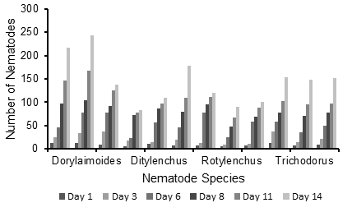
Fig. 6 – Species specific growth pattern upon cultivation on NGM.
Cultivation on treated NGM
The growth in terms of individual numbers of Dorylaimoides in NGM treated with different concentration of waste water was represented in Table 2. After
10 days in treated NGM, the response of nematodes fluctuates according to the concentration of effluent water. In 20% there is highly significant decrease in number of nematodes as compared to control. Whereas, in 30% treated NGM there was gradual positive correlation in the form of elevation in number and size of nematodes. In 40% treated NGM the effect was positively correlated with the growth and size of nematode; also indicate highly significant increase in nematode numbers at day 10th. It was observed from the result that in 100% treated NGM the highly significant decline in nematode number was observed. From Table 2, Dorylaimoides sp. showed normal growth in 30% and 40% concentration of waste water while in 100% concentration of waste water no growth was observed. An investigation carried out by Chan (2011) showed that successful introduction of nematodes in sewage treatment plant to the petroleum contaminated cultures gives maximum number of nematodes 72 individuals/mL. Wastewater treatment plants (WWTP) represent major point sources for (micro) pollutants and TPs in urban water cycles. According to (Abbas et al., 2018) three of the four effluents significantly promoted the growth of C. elegans larvae (49–55% increased lengths).
Table 2
Response of Dorylaimoides sp. in different NGM treated
with increasing concentration of waste water
Nematode species | Conc. of waste water  in NGM (%) | Survival Number of Nematodes
Nematode species | Conc. of waste water  in NGM (%) | Day 1 | Day 3 | Day 5 | Day 8 | Day 10
Dorylaimoides sp. | Control#  00 | 10.33±0.33 | 32±1.15 | 67±1.15 | 97.33±0.67 | 145.33±1.2
Dorylaimoides sp. | 20 | 7.66±0.33* | 19±0.57* | 50.66±0.67* | 67±1.52** | 83.66±1.45**
Dorylaimoides sp. | 30 | 13.66±0.8* | 46.67±0.33* | 72.67±1.45* | 96.33±0.89 | 132±1.15*
Dorylaimoides sp. | 40 | 11±0.58 | 37.33±1.2* | 80.67±0.33* | 106.33±1.76* | 158.67±1.45**
Dorylaimoides sp. | 100 | 8.33±0.89* | 7.67±0.67* | 2.66±0.33** | 1.33±0.33** | 0**
Values are mean ± SEM* = Significant (p < 0.05), ** = highly significant (p < 0.001) (n=6).
# normal, fresh NGM
Maturity Index (MI)
The occurrence of soil disturbance is inversely related to the magnitude of the MI but positively interrelated with the PPI (Freckman & Ettema, 1993). The counter relationship between the (Plant Parasite Index) PPI and the MI is apparent from their response to applications of ammonium, nitrate fertilizers and sewage sludge. The nematode response in different waste water treated NGM indicated that MI increased from 20% to 40% in treated NGM and growth correlated to the MI also showed a positive response from 20% to 40% treated NGM. Losi et al. (2013) found that anthropogenic effects were found on nematode abundance, number of genera and maturity index. The multivariate structure of the nematode assemblages was clearly related to the level of contamination of their sediments.
Comparing the values of MI that are attained from the treated NGM with that of the EQS (Ecological Quality Status) given by (Ürkmez et al., 2014) indicates that MI values in 40% treated NGM are much closer to the higher values > 2.8 suggesting environmental disturbance. The MI value for 30% treatment is much closer to the (<2.8 to >2.6) which is good indicator of environmental pollution. While in 20% treated NGM the MI value of nematode was 1.68 much closer to that of > 2.2 and this indicates increased environmental disturbance. This data suggests that if the MI value start to decline it leads to less growth and there is negative effect on nematode population. The MI value for 100% treated NGM indicates bad environmental health (Table 3). As at this concentration the nematode species becomes sensitive to environmental changes and are unable to survive.
Table 3
Difference in Maturity Index of Dorylaimoides sp. during treatment
Concentration of effluent water | Maturity index | Growth of nematodes
20% | 1.68 | Bad
30% | 2.64 | Good
40% | 3.18 | High
100% | 0.00 | Bad
CONCLUSIONS
The results of our study point out that the MI of Dorylaimoides may give us clues about the environmental status of the areas of their occurrence. These indices may serve in monitoring agricultural areas and areas near by the WWTP outlets. However, it was also found that Dorylaimoides sp. nematode response changes according to environment and in some treated group it acts as sensitive and in other treated groups it acts as the tolerant. It can be concluded that Dorylaimoides species are able to survive under stressful condition and can be used as bioremediating agent for removal of environmental pollutants and also helpful in environmental monitoring of different areas.
Acknowledgements: Authors are thankful to Prof. R. J. Verma, Head, Department of Zoology, Biomedical Technology and Human Genetics, University School of Sciences, Gujarat University, Ahmedabad for his constant encouragement. Authors also acknowledge Gujarat University for providing the necessary laboratory facilities and requirements throughout the research.
REFERENCES
ABBAS A., VALEK L., SCHNEIDER I., BOLLMANN A., KNOPP G., SEITZ W., SCHULTE-OEHLMANN U., OEHLMANN J., WAGNER M., 2018, Ecotoxicological impacts of surface water and wastewater from conventional and advanced treatment technologies on brood size, larval length, and cytochrome P450 (35A3) expression in Caenorhabditis elegans. Environmental Science and Pollution Research, 25 (14): 13868–13880.
BONGERS T., 1990, The Maturity Index: An Ecological Measure of Environmental Disturbance Based on Nematode Species Composition. Oecologia, 83 (1): 14–19.
BONGERS T., ALKEMADE R., YEATES G.W, 1991, Interpretation of Disturbance-Induced Maturity Decrease in Marine Nematode Assemblages by Means of the Maturity Index. Marine Ecology Progress Series, 76: 135–142.
CHAN H., 2011, Biodegradation of petroleum oil achieved by bacteria and nematodes in contaminated water. Separation and purification technology, 80 (3): 459–466.
COBB N.A., 1918, Estimating the nema population of soil, with special reference to the sugar-beet and root-gall nemas, Heterodera schachtii Schmidt and Heterodera radicicola (Greef) Müller, and with a Description of Tylencholaimus aequalis n. sp. U.S. Dept. of Agriculture. Bureau of Plant Industry. Office of Agricultural Technology.
FRECKMAN D.W., ETTEMA C.H., 1993, Assessing Nematode Communities in Agroecosystems of Varying Human Intervention. Agriculture, Ecosystems & Environment, 45 (3–4): 239–261.
GRZELAK K., GLUCHOWSKA M., GREGORCZYK K., WINOGRADOW A., WESLAWSKI J.M., 2016, Nematode Biomass and Morphometric Attributes as Biological Indicators of Local Environmental Conditions in Arctic Fjords. Ecological Indicators, 69: 368–380.
HOOPER D.J., HALLMANN J., SUBBOTIN S.A., 2005, Methods for Extraction, Processing and Detection of Plant and Soil Nematodes. In: Luc M., Sikora R.A. and Bridge (Eds.), Plant Parasitic Nematodes in Subtropical and Tropical Agriculture, 2nd Edition, Oxford University Press, 53–86.
MORENO M., GAOZZA L., ROVERE A., FIRPO M., MARQUES J.C. & ALBERTELLI G., 2013, The use of nematodes in assessing ecological conditions in shallow waters surrounding a Mediterranean harbour facility. Estuarine, Coastal and Shelf Science, 130: 209–221.
MEKETE T., DABABAT A., SEKORA N., AKYAZI F., ABEBE E. (comps)., 2012, Identification key for agriculturally important plant-parasitic nematodes. Prepared for the International Nematode Diagnosis and Identification Course 2012 – A manual for nematology, Mexico, D.F.: CIMMYT.
SCHWINGHAMER P., 1981, Extraction of Living Meiofauna from Marine Sediments by Centrifugation in a Silica Sol-Sorbitol Mixture. Canadian Journal of Fisheries and Aquatic Sciences, 38 (4): 476–478.
STIERNAGLE T., 2006, Maintenance of C. elegans. Worm Book. The on-line review of C. elegans biology.
TARJAN A.C., ESSER R.P., CHANG S.L., 1977, Interactive Diagnostic Key to Plant Parasitic, Freeliving and Predaceous Nematodes. Journal of the Water Pollution Control Federation, 49: 2318–2337.
ÜRKMEZ D., SEZGIN M., BAT L., 2014, Use of Nematode Maturity Index for the Determination
of Ecological Quality Status: A Case Study from the Black Sea. Journal of Black Sea/Mediterranean Environment, 20 (2): 96–107.

Received … | *Department of Zoology, Biomedical Technology and Human Genetics, University School of Sciences, Gujarat University-380009, Ahmedabad, Gujarat, India  e-mail: zankhana3pandit12@gmail.com

